# **Optical CRM Software Management**

# **-Periyasedhu K**

**Introduction**  
Optical CRM typically refers to Customer Relationship Management (CRM) software specifically designed for optical businesses, such as optometry practices or eyewear retailers. These CRM systems are tailored to manage customer interactions, sales, and appointments within the optical industry. They may include features like patient scheduling, prescription management, inventory tracking for eyeglasses and contact lenses, marketing automation, and customer communication tools. Optical CRMs help streamline operations, enhance customer service, and improve business efficiency in optical-related businesses. <https://youtu.be/qmrmPI8w6i4?si=I_0pCyAG2myO4tPt>

[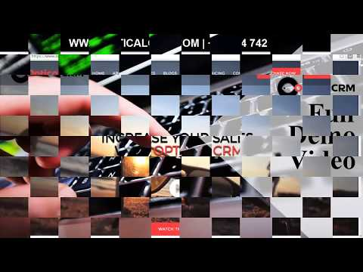](https://youtu.be/qmrmPI8w6i4?si=I_0pCyAG2myO4tPt)

Optical CRM software is designed to meet the specific needs of businesses in the optical industry, such as optometrists, ophthalmologists, and eyewear retailers.

* Inventory management
* Prescription management
* Customer Relationship Management
* Patient Management
* Sales and Invoicing
* Appointment Scheduling
* Reporting and analytics
* Marketing and Patient communication
* compliance and security

**Dashboard:** [**https://youtu.be/7yFe80OrA9s?si=-fqkadnxf_PBYuvE**](https://youtu.be/7yFe80OrA9s?si=-fqkadnxf_PBYuvE)

[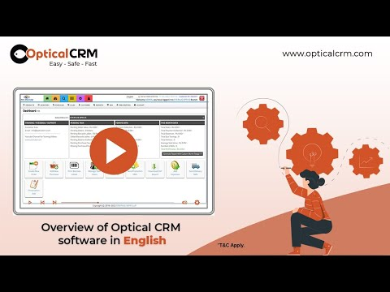](https://youtu.be/7yFe80OrA9s?si=-fqkadnxf_PBYuvE)

**Specific POS Billing Page Details:**

When developing an optical CRM that integrates with a POS system, there are specific points that make the POS efficient and convenient. These points set an optical POS apart from a normal POS and cater to the unique needs of optical practices.

**Inventory Management:**  
**Features**: Specialized inventory management for optical products like sunglasses, frames, lenses, contact lenses, accessories, and solutions.  
**Details Tracked**: Product-specific details such as frame size, Design, Axis, vision, color, lens material, and prescription types.  
**Benefits**: Ensures accurate tracking and availability of optical products, reduces overstock and stockouts.

**Prescription Management:**  
**Features**: Manages all optical prescriptions, including sphere, cylinder, axis, add, and prism values.  
**Details Tracked**: Comprehensive prescription details for glasses and contact lenses.  
**Benefits**: Allows for easy storage and retrieval of patient prescriptions, ensuring accuracy in fulfilling orders.

**Customer Relationship Management:**  
**Features**: Tracks patient history, prescription records, and appointment scheduling. **Details Tracked**: Patient interactions, preferences, and purchase history.  
**Benefits**: Enhances patient care and engagement, improves loyalty and repeat visits.

**Patient Management:  
Features**: Maintains detailed patient records.  
**Details Tracked**: Personal information, prescription history, appointment history, and insurance details.  
**Benefits**: Provides a comprehensive view of patient interactions and health history, aids in personalized care.

**Sales and Invoicing:**  
**Features**: Generates invoices with detailed prescription information, frame and lens details, insurance claims processing and Sales challans.  
**Details Tracked**: Sales transactions, product details, create new order, pending order , order tracking and insurance claims.  
**Benefits**: Ensures accurate billing, streamlines insurance processing, and reduces billing errors.

**Appointment Scheduling:**  
**Features**: Scheduling for eye exams and follow-up appointments.  
**Details Tracked**: Appointment dates, times, respected doctors and patient information.  
**Benefits**: Integrates with patient records and prescriptions, improves scheduling efficiency and patient management.

**Detailed Reporting:**  
**Features**: Provides detailed reports on sales and inventory.  
**Details Tracked**: Sales by prescription type, frame style, lens material, and patient demographics.  
**Benefits**: Tracks sales and inventory trends, aids in business decision-making, and helps in identifying growth opportunities.

**Marketing and Patient communication:  
Features**: Facilitates communication with patients through SMS, emails, reminders and promotional offers.  
**Details Tracked**: Patient communication history, preferences, and responses. **Benefits**: Enhances patient engagement, improves appointment adherence, and drives sales through targeted promotions.

**Compliance and Security:**

**Features**:

* Compliance with healthcare-specific regulations .
* Advanced encryption for data storage and transmission.
* Strict access controls for sensitive information.
* Secure communication channels.

**Details Tracked**: Patient health information, prescription records, and communication logs.

**Benefits**: Ensures the protection of patient data, meets regulatory requirements, and builds patient trust.  
  
**New Features to Integrate in Existing POS**

**Lens**:

* Lens details
* Lens vision
* Lens axis

**Lens Details:**The following are how the calculations are made and stored for each vision types:1. **Visual Acuity**:

* **Snellen Chart**: Measures clarity or sharpness of vision.

Example: 20/20 vision.

* **Refraction**: Determines the exact prescription needed for glasses or contact lenses.

2. **Refractive Errors**:

* **Myopia (Near sightedness)**: Difficulty seeing distant objects.
* **Hyperopia (Farsightedness)**: Difficulty seeing close objects.
* **Astigmatism**: Distorted vision due to an irregularly shaped cornea or lens.
* **Presbyopia**: Age-related difficulty in seeing close objects.

3. **Prescription Components**:

* **Sphere (SPH)**: Indicates the lens power needed to correct nearsightedness or farsightedness.
* **Cylinder (CYL)**: Indicates the lens power needed to correct astigmatism.
* **Axis**: Specifies the orientation of astigmatism correction.
* **Add**: Additional magnifying power for bifocals/progressive lenses.

**Example**:

**1. Myopia (Near sightedness)**

**Variables**:

* **SPH (Sphere)**: Indicates the degree of near sightedness (-0.25 to -20.00).
  + **Values**: Negative values (e.g., -1.00, -2.50).
* **CYL (Cylinder)**: Indicates astigmatism correction if present (-0.25 to -6.00).
  + **Values**: Negative values if combined with myopia (e.g., -0.50, -1.25).
* **Axis**: Orientation of astigmatism correction if present (0 to 180 degrees).
  + **Values**: 0 to 180 degrees.

**2. Hyperopia (Farsightedness)**

**Variables**:

* **SPH (Sphere)**: Indicates the degree of farsightedness (+0.25 to +20.00).
  + **Values**: Positive values (e.g., +1.00, +2.50).
* **CYL (Cylinder)**: Indicates astigmatism correction if present (-0.25 to -6.00).
  + **Values**: Negative values if combined with hyperopia (e.g., -0.50, -1.25).
* **Axis**: Orientation of astigmatism correction if present (0 to 180 degrees).
  + **Values**: 0 to 180 degrees.

**3. Astigmatism**

**Variables**:

* **CYL (Cylinder)**: Indicates the degree of astigmatism (-0.25 to -6.00).
  + **Values**: Negative or positive values (e.g., -0.75, +1.25).
* **Axis**: Orientation of astigmatism correction (0 to 180 degrees).
  + **Values**: 0 to 180 degrees.

**4. Presbyopia**

**Variables**:

* **Add**: Additional magnifying power needed for reading or close work (+0.75 to +3.50).
  + **Values**: Positive values (e.g., +1.00, +2.00).

**5. Combination Prescriptions**

For patients with a combination of conditions (e.g., myopia and astigmatism, hyperopia and astigmatism), the prescription will include multiple components.

**Variables**:

* **SPH (Sphere)**: Corrects for myopia or hyperopia.
  + **Values**: Negative for myopia (-0.25 to -20.00), positive for hyperopia (+0.25 to +20.00).
* **CYL (Cylinder)**: Corrects for astigmatism (-0.25 to -6.00).
  + **Values**: Negative or positive.
* **Axis**: Specifies the orientation of the cylindrical power (0 to 180 degrees).
  + **Values**: 0 to 180 degrees.
* **Add**: Additional power for presbyopia (+0.75 to +3.50).
  + **Values**: Positive values.

**Lens vision:**Visual acuity points such as 12/12, 6/6, 6/18P, 6/24, 6/36, and HM (Hand Motion) describe the clarity or sharpness of vision as assessed during an eye examination using a Snellen chart or equivalent methods. These measurements help determine the type of lenses required to correct a patient's vision.  
**Understanding Visual Acuity Points:**

1. 12/12:
   * **Meaning**: The patient can see at 12 feet what a person with normal vision can see at 12 feet.
   * **Interpretation**: This is considered normal vision.
2. 6/6:
   * **Meaning**: The patient can see at 6 meters what a person with normal vision can see at 6 meters.
   * **Interpretation:** This is also considered normal vision. In many countries, including the UK, this is the standard measurement for normal vision.
3. 6/18P:
   * **Meaning**: The patient can see at 6 meters what a person with normal vision can see at 18 meters, with pinhole correction (P).
   * **Interpretation**: This indicates moderately reduced visual acuity. Pinhole correction helps determine if reduced vision is due to refractive errors.
4. 6/24:
   * **Meaning**: The patient can see at 6 meters what a person with normal vision can see at 24 meters.
   * **Interpretation**: This indicates significantly reduced visual acuity and may require corrective lenses.
5. 6/36:
   * **Meaning**: The patient can see at 6 meters what a person with normal vision can see at 36 meters.
   * **Interpretation**: This indicates severely reduced visual acuity and typically requires strong corrective lenses.
6. HM (Hand Motion):
   * **Meaning**: The patient can only detect hand movements close to their face.
   * **Interpretation**: This indicates very poor vision, often categorized as low vision or severe visual impairment.

**Prescription Module:**In this module in addition with customer/patient information we have to add the vision details clearly for further references of that person.

* Eyewear Prescription: This section is designed to store comprehensive eyewear details for each individual

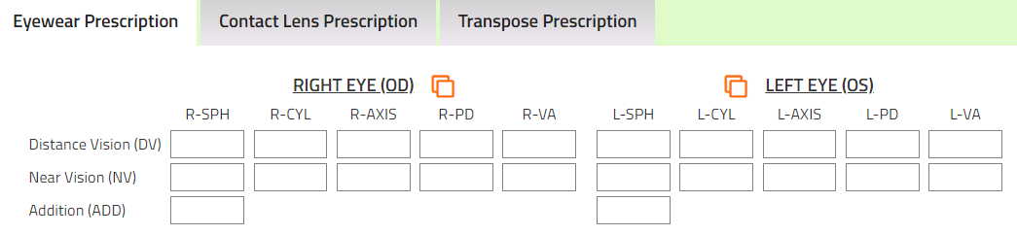

* Contact lens Prescription: This section enhances the eyewear prescription by providing additional details specific to contact lenses

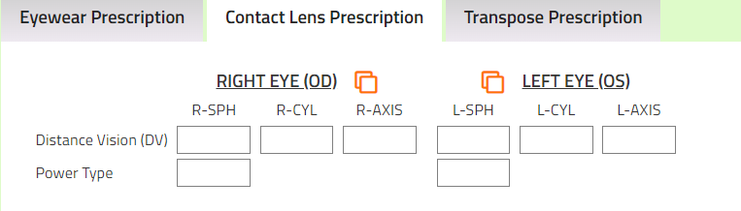

**By including prescription details in the billing**, optical stores can ensure that the correct lenses, contact lenses, frames, or other optical products are dispensed according to the patient's prescription.

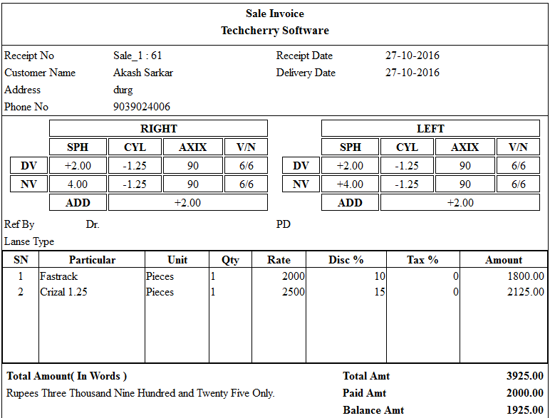

1.**Correct Lenses and Frames**: Ensures that the lenses and frames provided to the customer match their specific prescription requirements. This prevents errors in the dispensation of optical products.

2.**Custom Fit:** Allows for the customization of products based on individual prescriptions, which is crucial for vision correction and comfort.

3.**Reorder Convenience**: Helps customers reorder the same prescription without needing to visit the store again, as the details are readily available in the system

4. **Detailed Invoices:** Provides a clear, detailed invoice that includes all necessary prescription information, which can be useful for both customer and accounting purposes.

**Reports Module**:  
Develop new reports:

* Pending order report
* Order report
* Customer dues & advance reports
* Barcode report
* Eye testing records
* Damage stock reports
* Order tracking report
* Product code/SKU reports
* Appointment Records
* Prescription records
* Lens view grid report

**Barcode Module:**A Barcode Module in an Optical CRM (Customer Relationship Management) system is a feature that allows the generation, scanning, and management of barcodes for inventory items such as lenses, contact lenses, glasses, frames, and other optical products. This module typically includes several functionalities that help streamline operations, improve accuracy, and enhance the overall efficiency of the CRM system.  
**1. Barcode Generation:**

* Automatically generate unique barcodes for each product in the inventory.
* Support for different barcode formats (e.g., UPC, EAN, QR codes).

**2. Barcode Printing:**

* Print barcodes on labels or tags that can be attached to products.
* Integration with barcode printers for easy and quick printing.

**3. Barcode Scanning:**

* Use barcode scanners to quickly scan products during sales, inventory management, and other processes.
* Integration with point-of-sale (POS) systems for seamless checkout and billing.

**B2B Sales:**

Branch-to-branch sales in an Optical CRM system refer to transactions where products or inventory are transferred between different branches or locations of the same optical retail chain. This feature is particularly important for multi-branch operations and provides several benefits.

* Balancing Stock Levels
* Reduced Stockouts
* Enhanced Availability
* Customer Satisfaction
* Sales Transactions
* Centralized Ordering
* Internal Transfer Pricing

**Database Design:**To organize the existing itemmaster column effectively, we need to update tables specifically for optical-related details. These tables will be categorized into frames, sunglasses, lenses, contact lenses, solutions, and other related items. Each table will contain relevant fields to accurately describe the attributes of each product type.  
  
The fields related to create opticals related tables include**(code, name, color, size, gender, shape, temple design, bridge size, details, vision, coating, design, index, number, addition, axis, base curves, diameter, materials, modality, validity, power type, variants, package type, size)**  
In addition with existing tables we have to design further new tables to store the details of our lens and other details.

**Eyewear Prescription:** eyewearPrescriptionId (Primary Key), customerId (Foreign Key), eye (left/right), sphere, cylinder, axis, addition, prism, base, PD (Pupillary Distance), doctorId(Foreign Key), datePrescribed

**Contact Lens Prescription:** lensPrescriptionId (Primary Key), customerId (Foreign Key),eye (left/right), base curve, diameter, sphere, cylinder, axis, addition, material, power type (e.g., spherical, toric), doctorId (Foreign Key), datePrescribed

**Prescription Details:** prescriptionId (Primary Key), lensPrescriptionId(Foreign Key) , eyewearPrescriptionId(Foreign Key) , customerId (Foreign Key), prescriptionType (e.g., eyewear, contact lens),details (e.g., notes from the doctor)

**Orders Table :** orderId (Primary Key), customerId (Foreign Key), productid(Foreign Key), orderDate, totalAmount, status (e.g., pending, completed), shippingAddress, deliveryDate, paymentStatus.

**Sales Transactions:** Id, orderId(Foreign key),billId(Foreign Key), transactionDate, paymentMethod , paymentAmount, discount, pendingAmount , transactionStatus.

**Appointment Records:** appointmentId (Primary Key), customerId (Foreign Key), doctorId (Foreign Key), appointmentDate, purpose (e.g., routine checkup, prescription update), notes

**Barcode:** barcodeId (Primary Key), productCode (Foreign Key to relevant product tables), barcodeValue, createdDate.

**Pros:**

1. Increases efficiency and user satisfaction as the software is designed specifically for our business.

2.Add only important and required features based upon our business requirement

3.It's possible to Integrate with ERP and POS ensuring that all customer interactions are recorded and accessible.

4. Implement robust security measures to protect data during transfer and storage.

5. Automates workflows and data transfers between systems, reducing manual effort and minimizing errors.

6. Design the integration to handle increasing data volumes and additional functionalities as our business grows.

7. Including prescription details in the bill can be beneficial for both the customer and the business. It provides a clear record of the prescribed items, ensuring transparency and reducing the likelihood of errors or misunderstandings.

**Cons:**

1.Avoid adding too many features that don't meet our requirement, it leads to slow performance and complex to use.